This document is to give a quit lesson on using excel to manipulate your data.

First run the export to excel button in the database. This will create a file on the c drive named SCORETABLE.XLS

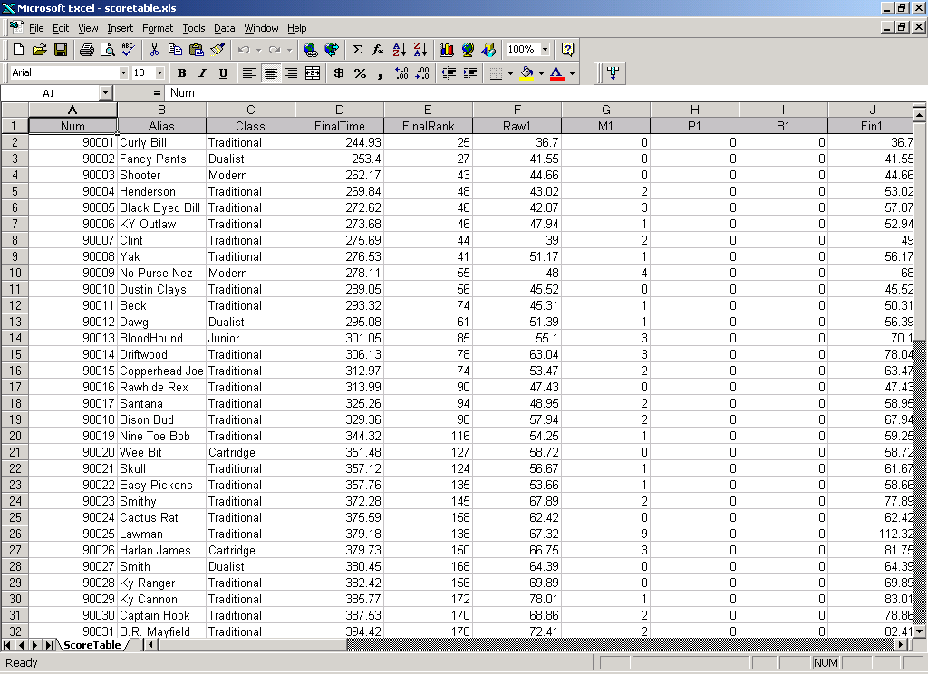
Open the scoretable.xls file in excel. ( or archivescoretable.xls if using an archived match )

Click the top left box ( where the column headings and row numbers meet ) this selects the entire table. )
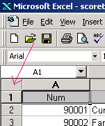

The data should now be highlighted

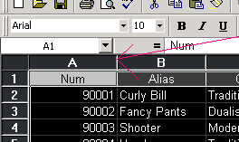
Then double click the line between the first and second column heading. This will resize ALL columns to their minimum size.

While the entire database is selected, Choose DATA and SORT and sort by either the FinalTime or FinalRank. This puts everyone in order.

You can now use excel to print and size the scores on 1 page or a couple of pages depending on the number of shooters

