Tutorial

Start RoundUpTutor.mdb
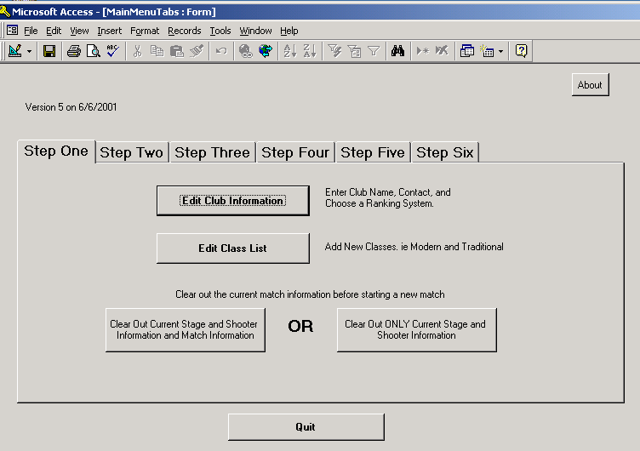

The Step One Tab should be showing.

Click on the “Edit Club Information” button
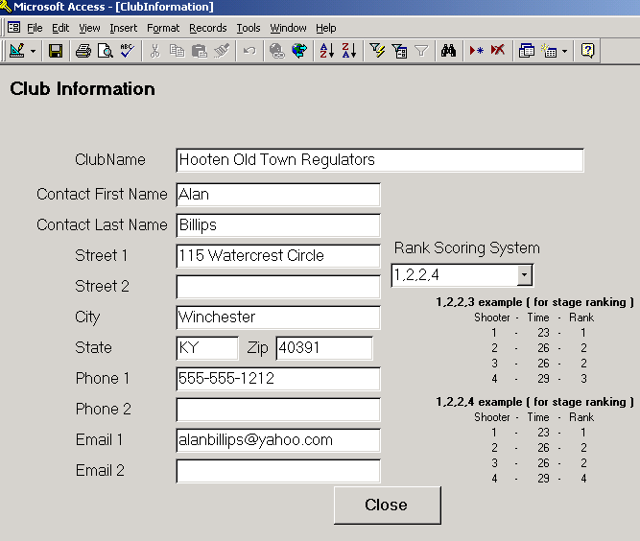
Enter the Name of your Club and the Contact Information. This information can be used to create return addresses on mailing labels.

If using Rank Scoring, choose the way you want the ties to occur. 1,2,2,4 is the default. Examples are shown.

Click the “Close” Button

Click on the “Edit Category List” Button
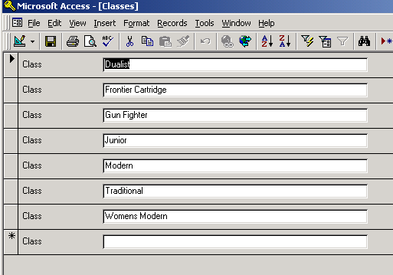
This is where you can add Names of categories.

You can delete or change the name of categories. Press the button beside the category you want to change or enter a new name for. This will also change the spelling of the associated shooters that were in that category.

Archived matches are not changed.

The key is to make sure the spelling of each shooters category are the same. Each spelling is considered a different category.

For this tutorial, leave the categories alone and click the “Close” button.

Note: Do not use an Apostrophe ( ‘ ) in the names of categories or anywhere else.

Click the “Clear Out Current Stage and Shooter Information and Match Information” button. We do this at the start of a new match.

Answer “Yes” to the question about being sure you want to clear the data. This warning is to make sure that you have already “Archived” the last matches data. Archive will be explained later.

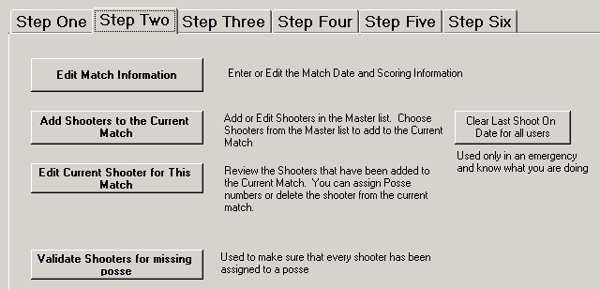
Click on the Step 2 Tab

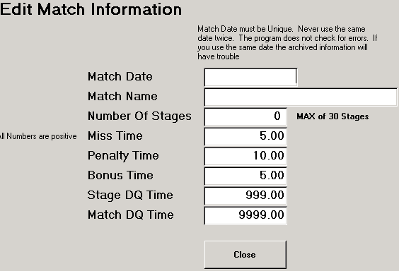
Click the “Edit Match Information” button.

Enter a Match Date. Use 03/05/2000 for this tutorial.
You MUST enter a match date AND the date must be unique. Never use the same date twice. This will allow you to look at old archived matches.
NOTE that I do not check for duplicate dates, you must take this responsibility.
You MUST enter a Match Name. This is printed on reports. If you do not want a match name, enter a period ( . ). Enter “Test Match” for this tutorial.

Enter the Number of Stages. Enter 2 for this tutorial.

You may change the default times if wanted. All times are entered as a positive number. The program knows to add or subtract these numbers.

Click the “Close” button

Click the ”Add shooters to the Current Match” button
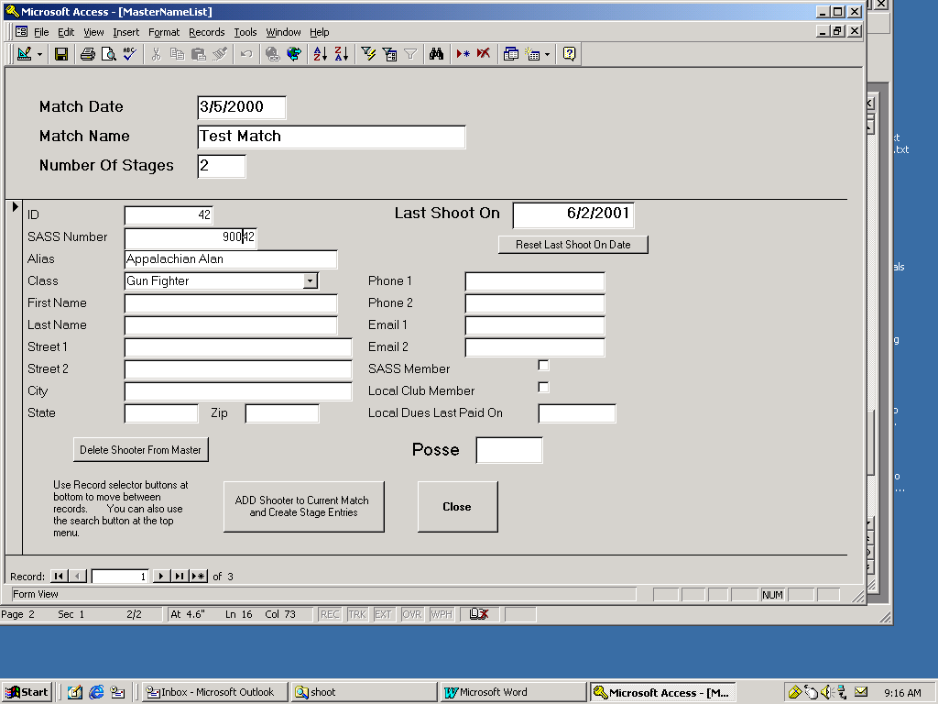
Three shooters are already entered for you. Pretend that they have shot here before. You never have to reenter a shooter that has shot before. When filling out information, you can use the TAB key to move from field to field.

The list comes up in Alphabetical Order.
Each shooter MUST have at least a SASS Number, Alias, and Class.

Click the Sass Number Field so that the cursor is in that field. Click either the Button or hold down the Ctrl key and press F

This will bring up the Find window. Type in 90031 and click “Find First” then click “close”

This is one way to find a particular shooter. You can search in any field.

When the shooter Captain Joe shows up, Confirm his information and if needed, change the class he will be shooting in for this match. Leave Joe as a Traditional shooter.
Click in the field to the right of Posse. Type the Number 1

Click “ADD Shooter to Current Match and Create Stage Entries” This adds him to our current match. Notice that the “last shoot on” date has changed.
Click the arrow in the bottom left corner a couple of time to you see Appalachian Alan on the screen. Notice that the Posse number stays the same.
Click “ADD Shooter to Current Match and Create Stage Entries”

Click the arrow to add a new shooter to the master list.
Type in SASS number 90099, press the Tab key, Type “Big Man” as the Alias, press the Tab key, Use the arrow and click on the class Traditional.

Change the Posse Number to 2

Click “ADD Shooter to Current Match and Create Stage Entries”

Click Close.

You can use “Edit Current Shooter for This Match” to change information on the shooters that you have already added to the current match. For example, you may need to change Posse Numbers or add a Number for someone you forgot.

Click “Validate Shooters for missing posse” you should receive a “Validation Complete” answer. If you had forgot to assign a posse number to a shooter, the sass number of the shooter would have been shown and you could use edit current shooter to make changes.
Click OK on the message.

Click Step 3
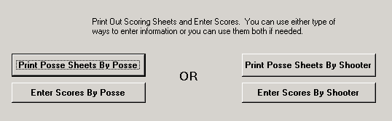
You can use the type of Posse Score sheets that you like the best. The “Posse Sheets By Shooter” work well if you decided to use blank preprinted sheets.

For this Tutorial, Click “Print Posse Sheets By Posse” This will bring up a print preview screen. If you want to print to the printer, Choose FILE and then PRINT or press Ctrl + P or click the printer icon. This selection prints a sheet for each posse per stage and would allow you to collect stage score sheets as they are completed.

You do not need to print the sheets for this tutorial

Click the “Enter Scores By Posse” button
Click the down arrows and choose 1 for both Posse and Stage
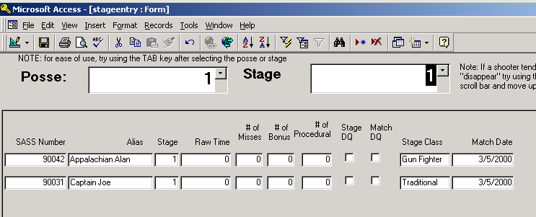

Press the TAB key until you are in the Raw Time Field for the first shooter ( you could also click in the field but the TAB key is easier) NOTE: the Enter key also works and can be used with the number pad.

Enter the following 21.24 TAB 2 TAB TAB TAB 25.7 TAB TAB TAB 1 TAB
We will not be DQ ing any one for this tutorial, but you put a check on the box if a stage DQ. If Match DQ, you must put a check in the appropriate box on every stage for that shooter.

Click the down arrows and leaving the Posse as 1 change the Stage to 2

Press the TAB key until you are in the Raw Time Field for the first shooter
Enter the following 33.54 TAB 1 TAB TAB 1 TAB 40.1 TAB TAB TAB TAB

Click the down arrows and Change the Posse to 2 change the Stage to 1
Press the TAB key until you are in the Raw Time Field for the first shooter
Enter the following 23.33 TAB TAB 1 TAB TAB

Click the down arrows and leaving the Posse as 2 change the Stage to 2
Press the TAB key until you are in the Raw Time Field for the first shooter
Enter the following 29 TAB 1 TAB TAB TAB

Click “Close”

Click the “Step Four” tab

Click the “Check for time less than one second”
This will tell you if you did not enter a time for someone.

Click “Calculate”

Click the “Step Five” tab
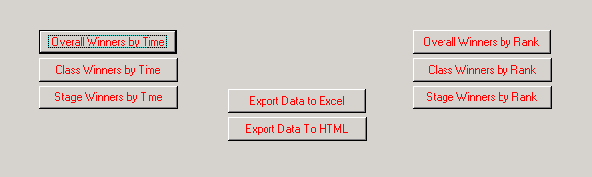
Try out the different reports.

You can export the information of an Excel file ot HTML file. These two button save a file to your C drive at c:\scoretable.xls for excel and c:\scoretable.html for internet.

The information exported is NOT in any order. You can use excel to put the shooters in total time order or rank order before printing.

When you are done with this match, I suggest you go to Step 6 and click the “Archive the Match and Clear Out Current Match” this will move all of the data to the archive table and clear out the current match making it ready for a new match.

You can review archive matches by using the Archive Tab.

