Roundup 17 Tutorial
Enhanced for 1024 x 768 resolution

Version 17 includes many bells and whistles including multi match support.

This tutorial will only cover the bare basic of what is needed to run a normal monthly match.
The other functions are shown in the document RoundupReference

Start RoundUp.mdb

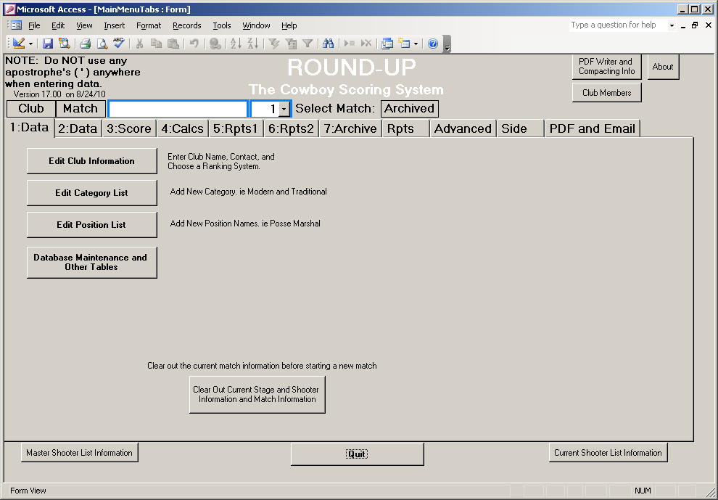

The TAB 1: Club Data should be showing.
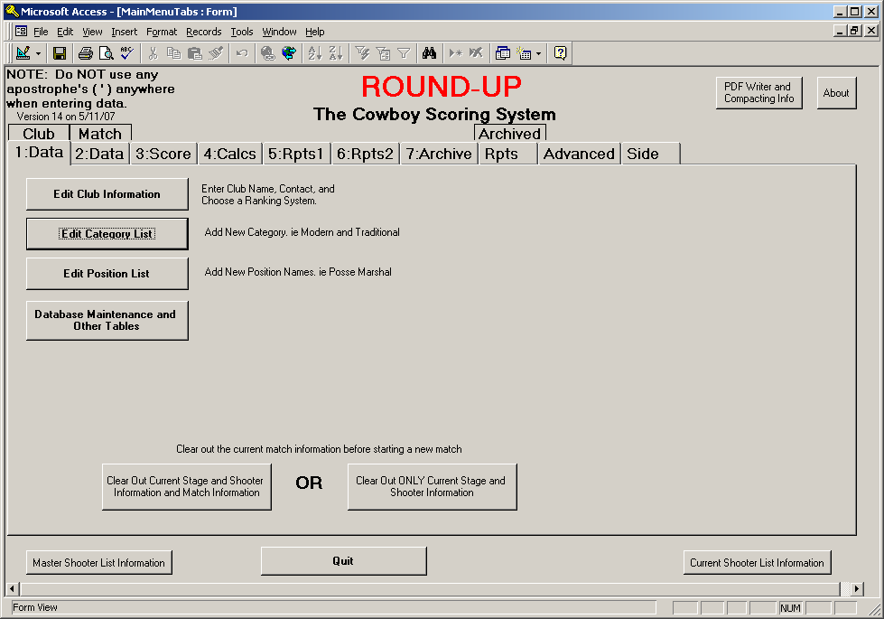
Click on the “Edit Club Information” button

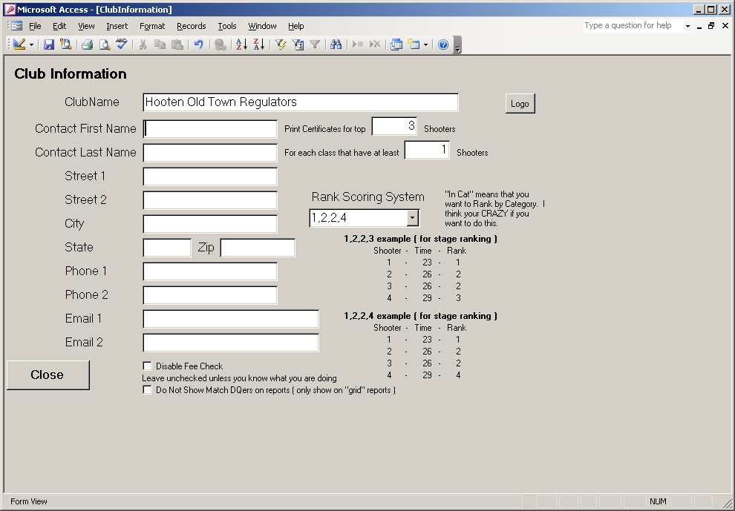
Enter the Name of your Club and the Contact Information. This information can be used to create return addresses on mailing labels.

For Certificates and Ribbon Labels, feel in the info needed for how many.

If using Rank Scoring, choose the way you want the ties to occur. 1,2,2,3 is the default. Examples are shown.
If you want to RANK IN CATEGORY, choose the In Cat 1,2,2,3

Disable Fee Check is for special users that want to be able to add fee information for shooters that have not yet been added to the match

Do Not Show Match DQers on reports controls if these shooters are listed on the grid reports or not.

Logo – This link will allow you to paste in a club logo.

Click the “Close” Button

Click on the “Edit Category List” Button

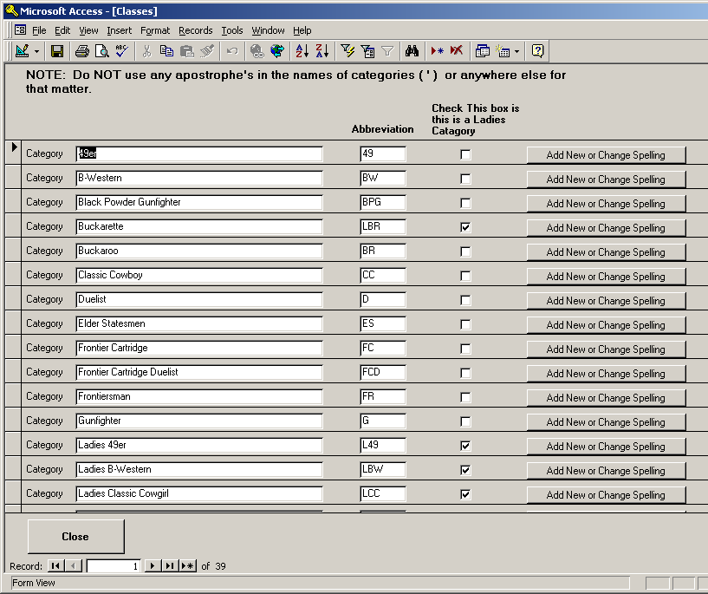
This is where you can add Names of categories.

You can delete or change the name of categories. Press the button beside the category you want to change or enter a new name for. This will also change the spelling of the associated shooters that were in that category.

Add New Categories at the bottom of the list.

To Delete a category, select it by clicking the box at the left of the row and press the delete key on the keyboard, or click at the top of the screen.

Archived matches are not changed.

The key is to make sure the spelling of each shooters category are the same. Each spelling is considered a different category.

Feel in the Abbreviation being sure not to duplicate yourself. Also click on the check boxes for the Ladies Categories. This is used to determine the top overall Mens and Ladies winners.
NOTE: it is possible that a top overall Lady may have entered a normal (ie mens) category. The reports will sometimes be listed as winner by Category and Winner by Gender. Category is controlled here. Gender is controlled in the shooter list.
For this tutorial, leave the categories alone and click the “Close” button.

Note: Do not use an Apostrophe ( ‘ ) in the names of categories or anywhere else. Including Alias Names.

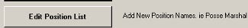

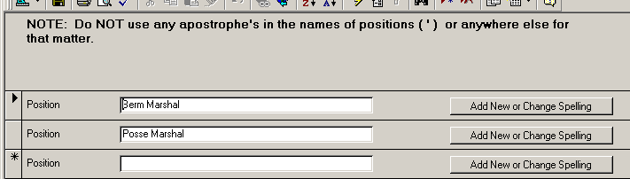
This is the Master list of POSITIONS. Can be used to track things such as Posse Marshals, EMT, Handicap, or other things.
Used in the Shooter Info.

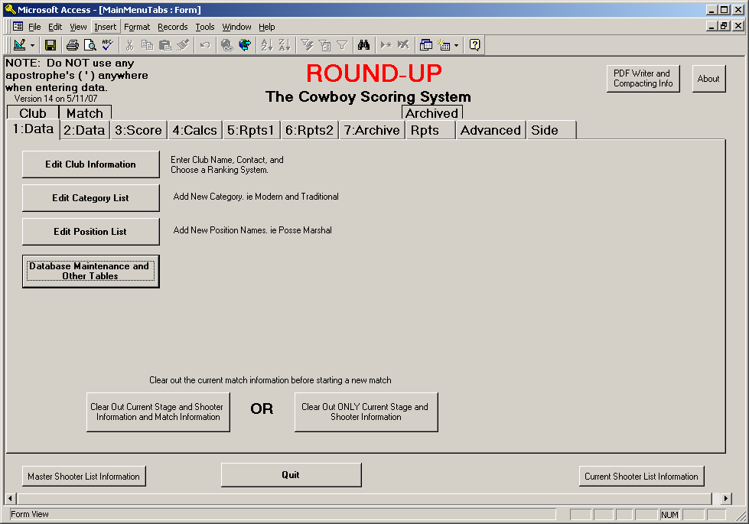
Used to Maintain other Master Tables. Explained in the Reference Document.

Click the “Clear Out Current Stage and Shooter Information and Match Information” button. We do this at the start of a new match.

Answer “Yes” to the question about being sure you want to clear the data. This warning is to make sure that you have already “Archived” the last matches data. Archive will be explained later.

Click on the TAB 2 (Match Data)
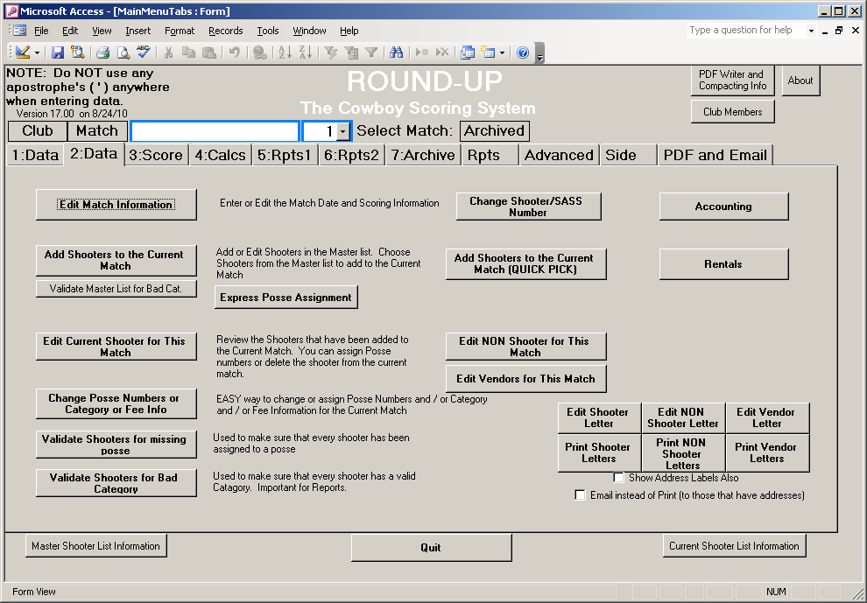

Click the “Edit Match Information” button.


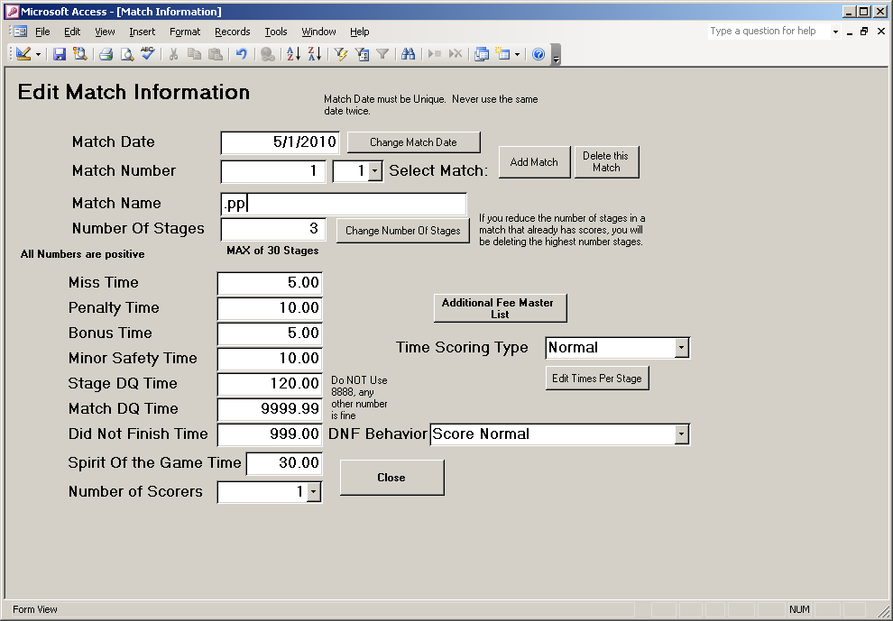
Enter a Match Date by clicking the button “Change Match Date”. Use 03/05/2000 for this tutorial.

You MUST enter a match date AND the date must be unique. Never use the same date twice. This will allow you to look at old archived matches.

You MUST enter a Match Name. This is printed on reports. If you do not want a match name, enter a period ( . ). Enter “Test Match” for this tutorial.

We will only be using Match # 1 for this tutorial. Multi Match is in the Reference document.

Enter the Number of Stages by clicking the button “Change Number of Stages”. Enter 2 for this tutorial.

You may change the default times if wanted. All times are entered as a positive number. The program knows to add or subtract these numbers.

Number of Scorers is usually 1, but can be used to have more than one person enter scores on the same computer and then compare them. More on that later.

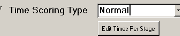

For Total Time Matches (ie not Rank Scoring) you can determine how stage and match DQ’s are handled.

NORMAL – uses the time entered at the left. Ie 999 for the time of a stage DQ
MAX PER STAGE – Uses the time entered for that particular stage as the MAX time. This is also the Max for a slow shooter that did not DQ
SLOWEST PLUS – If a shooter DQ’s, they get the time of the slowest shooter for that stage PLUS the time entered for that particular Stage
BUTTON “ Edit Times Per Stage” is where you pre determine the Max or Plus Time for each stage

This controls how a shooter that Did Not Finish is handled in the scores.
NORMAL : Shooter gets the stage dq time for each stage not shot and places accordingly.
DELETE FROM MATCH BUT LIST LAST : Disqualifies shooter from placing in match, but still lists his scores on the score sheet.

Click the “Close” button

Click the ”Add shooters to the Current Match” button
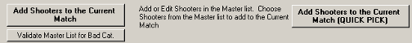
Three shooters are already entered for you. Pretend that they have shot here before. You never have to reenter a shooter that has shot before. When filling out information, you can use the TAB key to move from field to field.

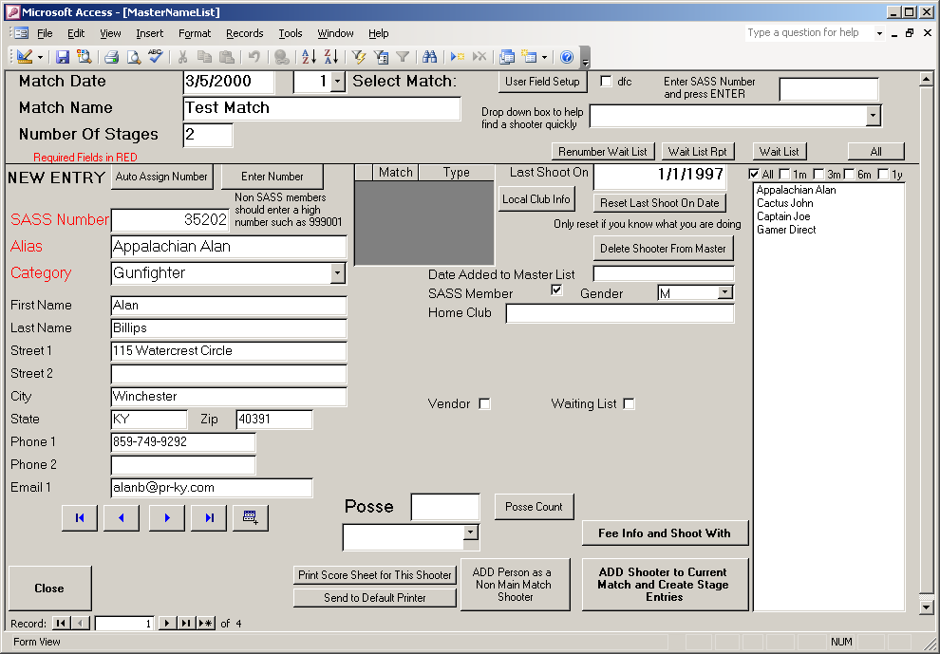
The list comes up in Alphabetical Order.
Each shooter MUST have at least a SASS Number, Alias, and Class.

Click the Sass Number Field so that the cursor is in that field. Type in 90031 and press the Enter Key on the keyboard.

When the shooter Captain Joe shows up, Confirm his information and if needed, change the class he will be shooting in for this match. Leave Joe as a Traditional shooter.
Click in the field to the right of Posse. Type the Number 1

Click “ADD Shooter to Current Match and Create Stage Entries” This adds him to our current match. Notice that the “last shoot on” date has changed.

Click the arrow in the bottom left corner a couple of time to you see Appalachian Alan on the screen. Notice that the Posse number stays the same.
Click “ADD Shooter to Current Match and Create Stage Entries”

Let’s now add a new shooter that is not in our list
AUTO ASSIGN will give the shooter a large number that is not already used. You can use this for shooters that are not SASS Members.
ENTER NUMBER is for those that have a number.
Click ENTER NUMBER

Type in SASS number 90099, press the Tab key, Type “Big Man” as the Alias, press the Tab key, Use the arrow and click on the class Traditional.

Change the Posse Number to 2

Click “ADD Shooter to Current Match and Create Stage Entries”

You can use the 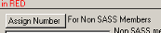button to have the computer assign you a number also.

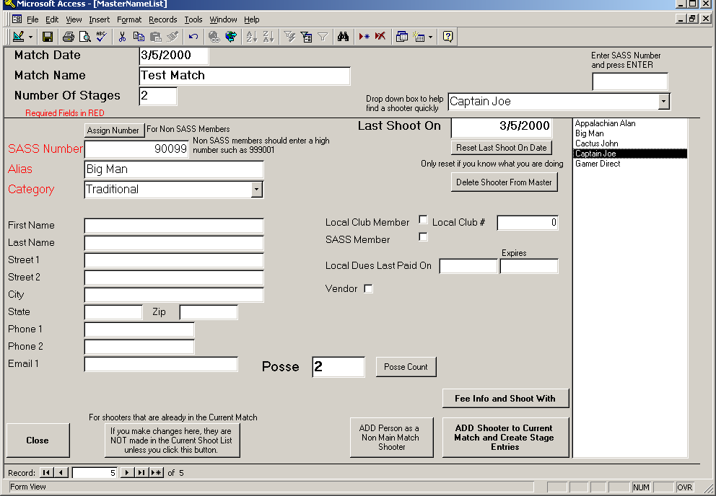
On the right side of the screen in the name list, Click on the name Cactus John.
Notice that the screen now shows Cactus John’s Info. Use this list to move around a lot easier.
Also you can choose the name from the drop down box at the top of the screen
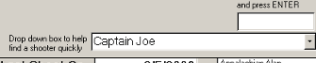

Click Close.

You can also add a NON shooter to the current shoot. Useful at a large match to track Fees , Dinner Tickets, Etc. Use the category “non shooter” for these people.

If you have already added a shooter to the current match, and then change the Category on this screen, the info for this person on the current match screen is NOT updated. Change category info, etc after adding on the Current Match Screen.

“Fee Info and Shoot With” is where you can track things such as Fees, Camping, Rentals, Etc. More on this Later

For large matches, Vendors can also be added. A vendor will have a sass number, alias, and category just like the shooters. Use the category “Vendor” and use the vendors company name as the alias.
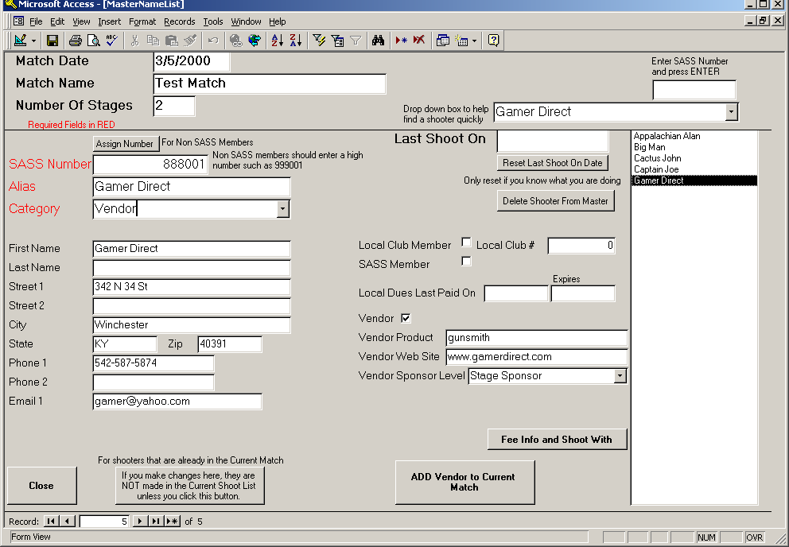

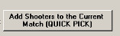 Currently this function is DISABLED
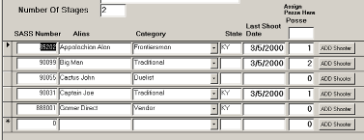
You can add Shooters to the Current Match using the Quick Pick also. To assign the posse number, type it in at the TOP of the list and then Click Add Shooter for those in that Posse.

To add new shooters, go to the bottom of the list and enter the SASS Number, Alias and Category

NOTE: If planning to enter the scores by shooter and not by posse, then the posse number does not really matter at all. Put everyone in posse 1.

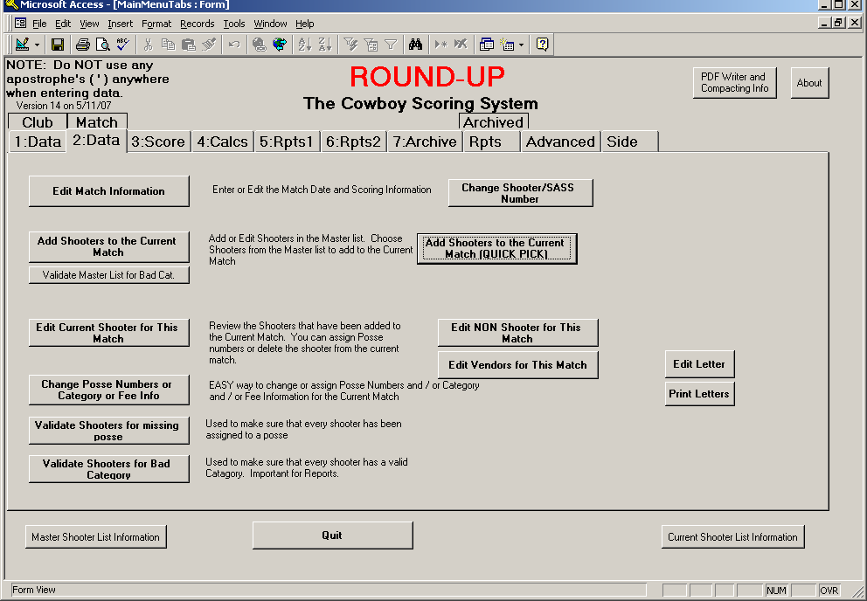
If wanted, you can use the Validate button to see if the people in you master list have a “valid” category. IE you may have deleted a category and still have people in the master list that had this category. At this point, it really does not matter if they are valid or not. It WILL be important to Validate the Current Match List.

You can use “Edit Current Shooter for This Match” to change information on the shooters that you have already added to the current match. For example, you may need to change Posse Numbers or add a Number for someone you forgot.
This is also where you would Delete a shooter from the match.

You can also edit some information using this button

Click “Validate Shooters for missing posse” you should receive a “Validation Complete” answer. If you had forgot to assign a posse number to a shooter, the sass number of the shooter would have been shown and you could use edit current shooter to make changes.
Click OK on the message.

Click “Validate Shooters for Bad Category” you should receive a “Validation Complete” answer. If a shooter is missing a category or for some reason has one that is not in the master list, then the sass number of the shooter would have been shown and you could use edit current shooter to make changes.
Click OK on the message.

Click TAB 3 Score
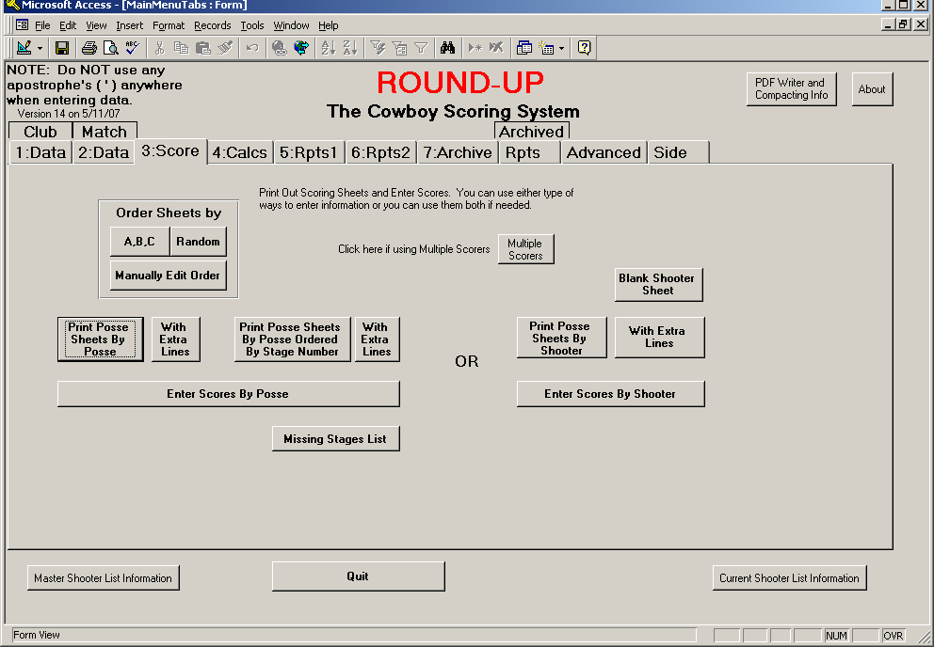

You can use the type of Posse Score sheets that you like the best. The “Posse Sheets By Shooter” work well if you decided to use blank preprinted sheets.

For this Tutorial, Click “Print Posse Sheets By Posse” This will bring up a print preview screen. If you want to print to the printer, Choose FILE and then PRINT or press Ctrl + P or click the printer icon. This selection prints a sheet for each posse per stage and would allow you to collect stage score sheets as they are completed.

You do not need to print the sheets for this tutorial

Click the “Enter Scores By Posse” button
Click the down arrows and choose 1 for both Posse and Stage
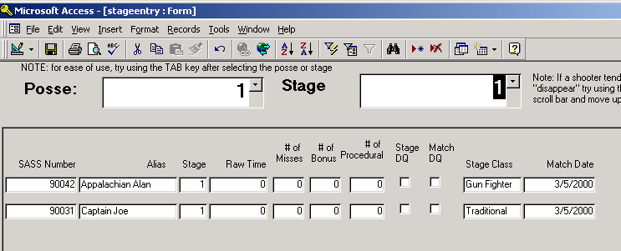

Press the TAB key until you are in the Raw Time Field for the first shooter ( you could also click in the field but the TAB key is easier) NOTE: the Enter key also works and can be used with the number pad.

Enter the following 21.24 TAB 2 TAB TAB TAB 25.7 TAB TAB TAB SPACEBAR TAB
We will not be DQ ing any one for this tutorial, but you put a check in the box if a stage DQ. If Match DQ, Click on the M next to Match DQ.
For DNF, click on D box

Click the down arrows and leaving the Posse as 1 change the Stage to 2

Press the TAB key until you are in the Raw Time Field for the first shooter
Enter the following 33.54 TAB 1 TAB TAB SPACEBAR TAB 40.1 TAB TAB TAB TAB
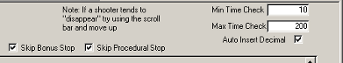
This area is used to change the way the screen works.
You can have the program give you a warning if you enter a score less than the Min or more than the Max.
Auto Insert Decimal will allow you to enter 2125 and the program will change it to 21.25 for 21 even enter 2100
The two skip button allows the TAB to skip these columns. You can still enter info in the column by using the mouse and clicking in the box

If wanted, you can use the Print Scores buttons to print a list to compare to the hand written sheet. I use this at the state match and have two people compare the score sheets before considering them Good.

Click “Close”

Click “Enter Scores by Shooter”
The list at the right shows the shooters that still needed scoring. NOTE: only those that still need scores are listed in the list. You can STILL get any shooter by using the drop down list at the top of the screen.
Click on the name Big Man
OR
Use the drop down box and choose Big Man
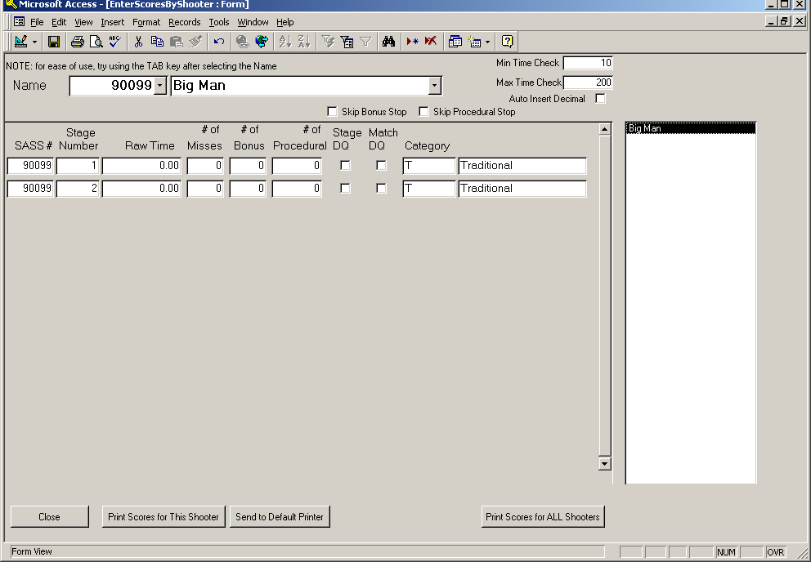

Press the TAB key until you are in the Raw Time Field for the first shooter
Enter the following 23.33 TAB TAB 1 TAB TAB
Enter the following 29 TAB 1 TAB TAB TAB

Click “Close”

Click TAB 4 Calcs
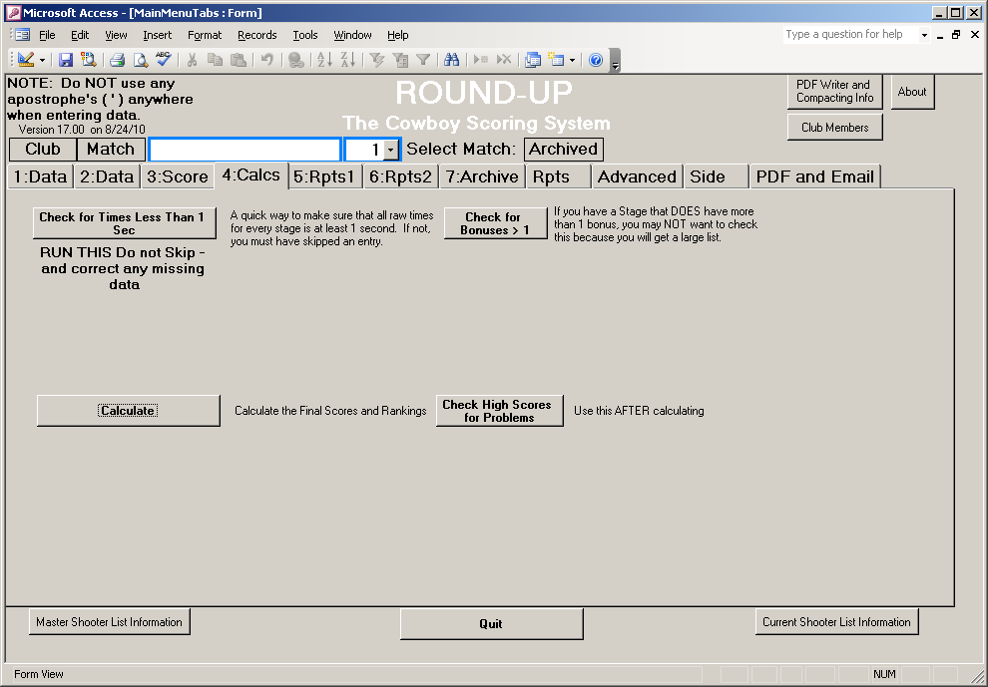
Click the “Check for time less than one second”
This will tell you if you did not enter a time for someone.

Click Check for Bonus > 1
This can be useful to see if someone got more than 1 bonus

Note: it may be OK to have more than one bonus.
You could make a bonus worth 1 sec and on one stage give a bonus of 2 for 2 sec and on another give 3 for 3 sec.

Click “Calculate” and WAIT for the OK
Note that you may receive a warning if someone has a score of 0 or more than one bonus or procedure. The Calculate WILL work, it is just a warning.
You may Calculate at any time to check the progress of scores. IE you may want to calculate on day 1 of a two day match.

Use “Check High Scores for Problems” This lists all scores highest to lowest. If you see a strange score such as 1235, then that is a RED flag to check that shooter. Ie it probably should have been 12.35

Click TAB 5 Reports1
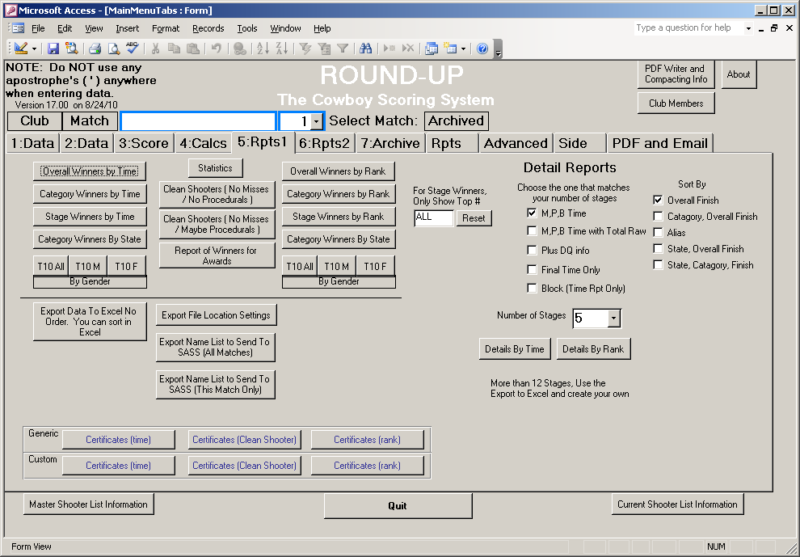
Try out the different reports.

You can export the information of an Excel. This saves a file to your hard drive at name specified in the “Location Settings”

For this Tutorial, try out the Overall Winners By Time and Category Winners by Time.

To use the grid reports that show each stage, choose the number of stages in the drop down list and then click either Time or Rank.

Note: there is no report for only 2 stages as we are doing here in this tutorial.

When you are done with this match, I suggest you go to TAB 7 and click the “Archive the Match and Clear Out Current Match” this will move all of the data to the archive table and clear out the current match making it ready for a new match.

You can revive archive matches by using the Archive Rpts Tab
That’s it for the Tutorial; More information is in the Reference Document.

