Using handhelds to take scores.

It is possible to use a handheld such as a Palm Pilot or Windows CE device.

I suggest that only those with good technical skills use handhelds.

Requirements:

- You need to already know how to use the handheld.

- You must already have some type of program for the handheld that allows you to link to an Microsoft Excel file. Some handhelds come with a program, others may need to have one purchased. I know of a few companies that make this software such as Quicksheets for the Palm Pilot.

- If you are going to use multiple handhelds on the same computer, have your resident computer guru help set up so you can dock them on the same cradle.

Using RoundUp with handhelds.

NOTE: Please test before using in a match. Also test this first. Following the instructions below, create a match and add a few shooters, Create Posse Excel Sheets and then immediately Import Posse 1. If you do not get an error, then everything is fine. If you get an error about missing an ISAM file, you need to download the ISAMFILE.EXE and install it. Then do this test again.

You can use the handhelds with only a few of your posses or with them all.

Start “RoundUp” and enter all of the match information as normal. Assign shooters to their posses etc.

When you are ready, Click on the Advanced Tab
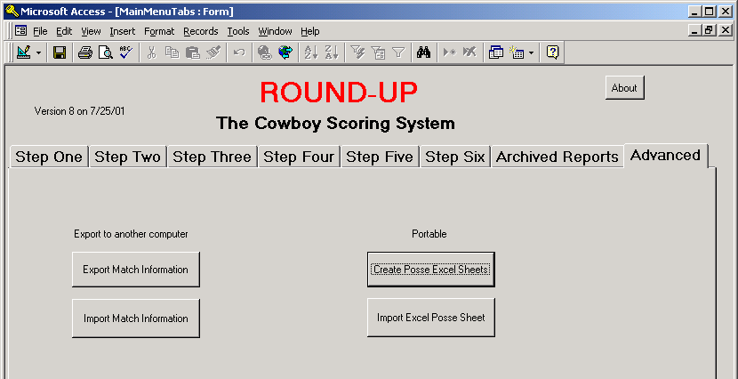

Click on the “Create Posse Excel Sheets” button.
This will create one excel document for each posse on the C drive names posse1.xls and so on.

Using your handheld software or the spreadsheet software, link the appropriate handheld to the posse documents that will be using it.

Take the handhelds into the field and use the spreadsheet program to edit the posseX.xls recording the raw time, misses, etc. The data downloaded to the handheld is in alphabetical order showing all of stage 1 first and then keep scrolling down to stage 2 and so on.

NOTE: I suggest you keep paper records as a backup.

When you are done recording your data, sync the handhelds back to the computer. If set up correctly, this will update the posseX.xls documents on the C drive.
Now in the RoundUp program, click the “Import Excel Posse Sheet”. You will be prompted for a posse number. Enter the number only. Example “3” for posse 3

The data will overwrite all information for posse 3 in the roundup program.

Since RoundUp asks you for the posse number one number at a time, you can see that it is possible to use a handheld on a few posses and enter the others manually. Just don’t import the posses that you manually entered the scores for.

After importing the data, you are ready to calculate scores.

