You can use 2 or more computers to score a match. Each computer will score 1 or more posses and then you will merge the data. Be sure to follow the directions completely.

I suggest that only those with good technical skills use multiple computers

Requirements:

- You need to have ROUNDUP version 8 and Access on all computers.

- Floppy Disks to transport information

NOTE: Please test before using in a match. Also test this first. Following the instructions below, create a match and add a few shooters, Create Posse Excel Sheets and then immediately Import Posse 1. If you do not get an error, then everything is fine. If you get an error about missing an ISAM file, you need to download the ISAMFILE.EXE and install it. Then do this test again.

Start “RoundUp” and enter all of the match information as normal. Assign shooters to their posses etc.

When you are ready, Click on the Advanced Tab
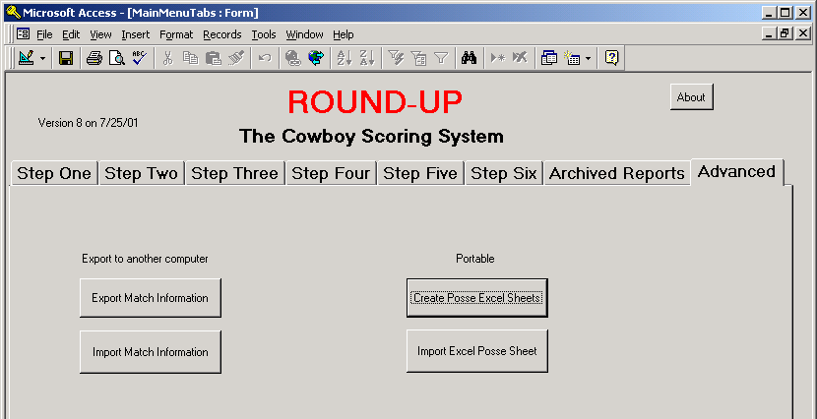

Click on the “Export Match Information” button.
This will create one excel document for each of the following on the root of the C Drive.
ClubInformation.xls
CurrentMatchInformation.xls
CurrentNameList.xls
CurrentStage.xls
Classes.xls
MasterNameList.xls

Copy these 6 files to a floppy disk

Copy from the floppy disk to the root C Drive of each of the other computers (“Slave” computer) you plan to use to score with

On the “slave” computer start Roundup and go to the Advanced Tab. Click the button “Import Match Information”. This will overwrite the local database with the master computer information.

NOTE that now all posse information is on every computer

Use Roundup as normal on all computers BUT only entering scores for the posses that you want to score on that computer.

Example
Computer 1 for Posses 1-3
Computer 2 for Posses 4-6
Computer 3 for Posses 7-9
Etc

When you are done scoring,

On each of the slave computers go to the Advanced Tab and under PORTABLE, click the button “Create Posse Excel Sheets”

This will create a file on the root C Drive named POSSExx.XLS where xx is the posse number. There will be one file for each posse, including the posses that you did not enter scores for.

Copy the POSSExx.XLS files to a floppy. NOTE you only need the posse numbers that you entered scores for. Ie 4-6 from computer 2 and 6-9 from computer 3 etc.

From the floppy, copy all of the xls files to the MASTER computer’s root C Drive

Now in the RoundUp program on the master computer , click the “Import Excel Posse Sheet”. You will be prompted for a posse number. Enter the number only. Example “3” for posse 3
The data will overwrite all information for posse 3 in the roundup program.

Do this for each of the posses that were scored on the slave computers.

The master computer now has all of the posse scores

After importing the data, you are ready to calculate scores.

